Registr |  |  | Val. | Binary, Zecimal | Hex
Canal 0 | Canal 1 | Functie
D8400 | D8420 | Com Format | 9600-8N2 | B 0001 0000 1000 1001  xx 485 xxxx-9600 2nn8 | H 1089
D8401 | D8421 | Protocol |  | B 0000 0000 0001 0001 | H 11
D8411 | D8431 | Mes-Mes-delay | 50 | K 50
D8414 | D8434 | Adresa Slave | 102 | K 102
D8415 | D8435 | Com status |  | B 0000 0000 0001 0001 | H 11

D8420 - Comminication Format
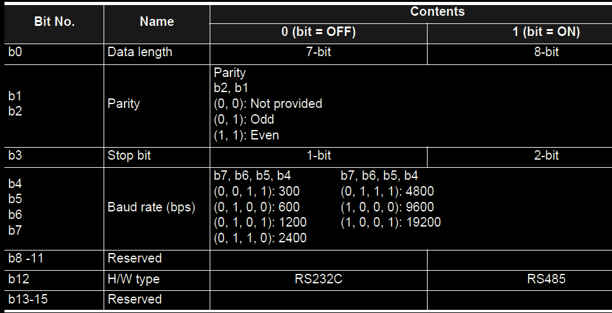

D8421 - Protocol Format
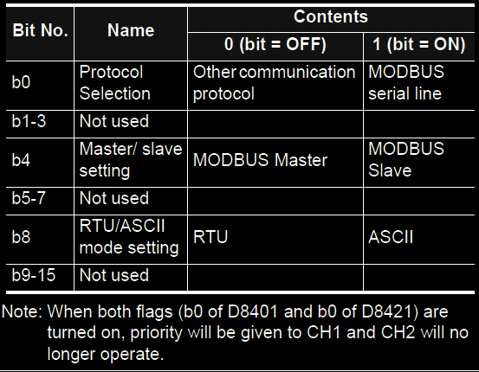
D8435
