Top of Form
Gammon Forum  See www.mushclient.com/spam for dealing with forum spam. Please read the MUSHclient FAQ!  Entire forum  Electronics  Microprocessors  Turn your Arduino into a capacitor tester ...
  Home | Users | Search | FAQ
  Username: | Register forum user name
  Password: | Forgotten password?

Bottom of Form

Turn your Arduino into a capacitor tester ...
Postings by administrators only.
Refresh page

Posted by | Nick Gammon Australia (21,805 posts) bio Forum Administrator
Date | Sun 14 Jul 2013 01:50 AM (UTC)  Amended on Wed 07 Sep 2016 10:31 PM (UTC) by Nick Gammon
Message
  This post describes making a capacitor tester from an Arduino with minimal parts.
  Theory
  First, the theory is covered at some length by Martin Lorton here:
  How to measure a capacitor with an oscilloscope (YouTube)
  I decided to reproduce his test results myself.
  I used his test circuit:
  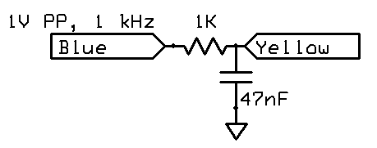
  Feeding in a 1 kHz signal (square wave) at 1V peak to peak, we see this:
  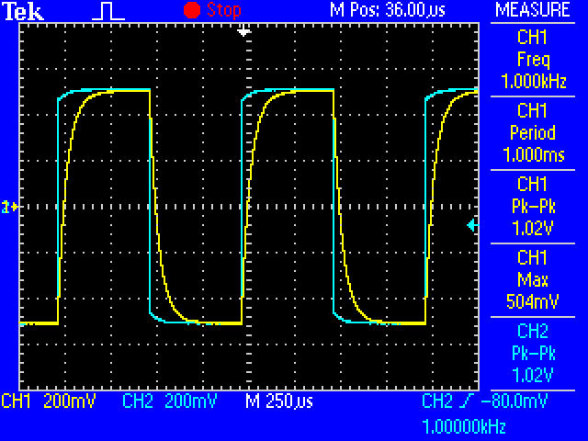
  Zooming in on one cycle, we find the point where the voltage reaches 63.2% (that is, 632 mV).
  We are choosing 63.2% because this is:
  1 - e^(-1) = 0.63212
  http://en.wikipedia.org/wiki/RC_time_constant
  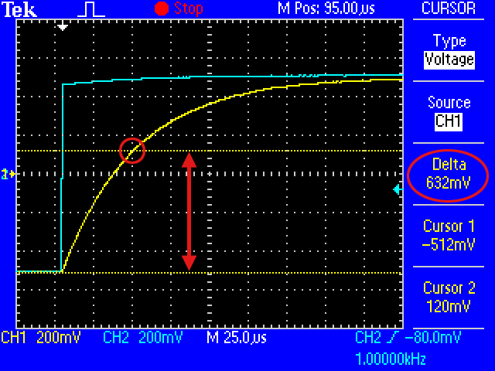
  Switching to the "time" cursor we measure how long it takes to charge to this point:
  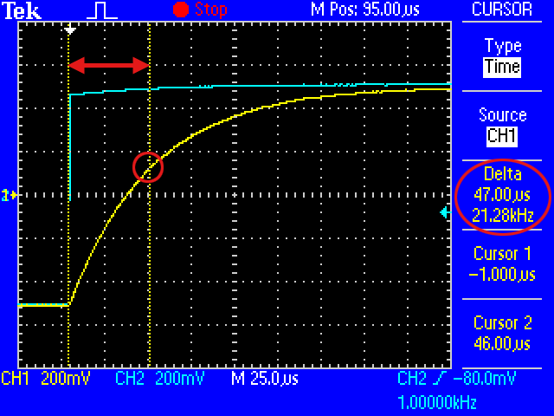
  From the Wikipedia article, we read:
  Quote:
  The RC time constant, the time constant (in seconds) of an RC circuit, is equal to the product of the circuit resistance(in ohms) and the circuit capacitance (in farads), i.e. τ = R * C.
  Thus C is equal to τ / R
  I measured 47 uS as the time, so thus the capacitance was:
  C = 0.000047 / 1000
  In other words, 47 nF, which is in fact the capacitor I used. So far so good, the theory agrees with practice.
  Simple tester
  Circuit:
  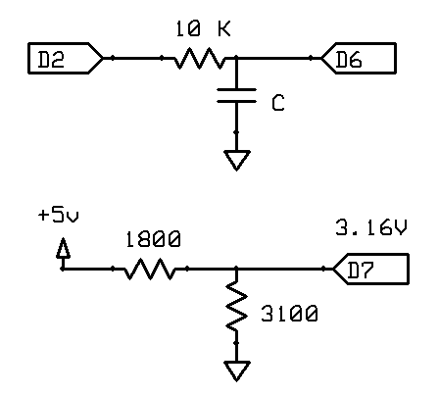
  The objective here is to find the time constant τ (tau) in the equation:
  τ = R * C
  Solved for C:
  C = τ / R
  So we want to charge the capacitor under test with a suitable voltage (eg. 5V from an Arduino output pin) and measure how long it takes to reach 63.2% of that voltage. So we need a reference voltage of 5 * 0.632, namely 3.16V.
  The voltage divider illustrated above should provide approximately that:
  Quote:
  Vout = Vin * (R2 / (R1 + R2))
  5 * (3100 / (1800 + 3100)) = 3.163
  You may need to use a few resistors (eg. 3 x 1K plus 100 ohms) to make up the 3100 ohm resistor.
  We now need to time the interval indicated by the arrow and stop when the rising edge reaches the reference voltage:
  The internal analogue comparator is just the thing for the job. We connect the reference voltage to the AIN1 pin (negative reference) and connect our capacitor to the AIN0 pin (positive reference) and then configure an interrupt on the rising edge. I chose a value of 10K for the resistor to give a reasonably slow charge time.
  A simple sketch follows:
  /*
  Capacitance meter
  Author: Nick Gammon
  Date: 27 June 2013
  Pulse pin (D2): Connect to capacitor via 10K resistor.
  Reference voltage of 0.632 of output pin (pulsePin) connected to D7.
  In my case I used 3.06V because I measured 4.84 on the 5V pin.
  Measure pin (D6) connected to first leg of capacitor, other leg connected to Gnd.
  Like this:
  Capacitor to test:
  D2 ----> 10K ----> D6 ----> capacitor_under_test ----> Gnd
  Reference voltage:
  +5V ----> 1.8K ---> D7 ---> 3.1K ----> Gnd
  */
  const byte pulsePin = 2;
  const unsigned long resistance = 10000;
  volatile boolean triggered;
  volatile boolean active;
  volatile unsigned long startTime;
  volatile unsigned long duration;
  ISR (ANALOG_COMP_vect)
  {
  // grab time quickly
  unsigned long now = micros ();
  if (active)
  {
  duration = now - startTime;
  triggered = true;
  digitalWrite (pulsePin, LOW); // start discharging capacitor
  }
  }
  void setup ()
  {
  pinMode (pulsePin, OUTPUT);
  digitalWrite (pulsePin, LOW);
  Serial.begin (115200);
  Serial.println ("Started.");
  ADCSRB = 0; // (Disable) ACME: Analog Comparator Multiplexer Enable
  ACSR = bit (ACI) // (Clear) Analog Comparator Interrupt Flag
  | bit (ACIE) // Analog Comparator Interrupt Enable
  | bit (ACIS0) | bit (ACIS1); // ACIS1, ACIS0: Analog Comparator Interrupt Mode Select (trigger on rising edge)
  } // end of setup
  void loop ()
  {
  // start another test?
  if (!active)
  {
  active = true;
  triggered = false;
  digitalWrite (pulsePin, HIGH); // start charging capacitor
  startTime = micros (); // remember when
  }
  // if the ISR noted the time interval is up, display results
  if (active && triggered)
  {
  active = false;
  Serial.print ("Capacitance = ");
  Serial.print (duration * 1000 / resistance);
  Serial.println (" nF");
  triggered = false;
  delay (3000);
  }
  } // end of loop
  With a 47 nF capacitor connected, I get this result:
  Started.
  Capacitance = 47 nF
  Capacitance = 46 nF
  Capacitance = 47 nF
  Capacitance = 46 nF
  Not too bad. But with a 6.8 nF capacitor we only get one decimal place:
  Capacitance = 6 nF
  Capacitance = 7 nF
  Capacitance = 7 nF
  Capacitance = 7 nF
  Capacitance = 6 nF
  Capacitance = 6 nF
  Capacitance = 7 nF
  Capacitance = 6 nF
  Capacitance = 7 nF
  Plus, the micros() function only returns time to the nearest 4 microseconds.
  Improved sketch using Timer 1
  A slightly more elaborate sketch uses Timer 1 with a prescaler of 1 to get a higher resolution timer.
  /*
  Capacitance meter
  Author: Nick Gammon
  Date: 27 June 2013
  Pulse pin (D2): Connect to capacitor via 10K resistor.
  Reference voltage of 0.632 of output pin (pulsePin) connected to D7.
  In my case I used 3.06V because I measured 4.84 on the 5V pin.
  Measure pin (D6) connected to first leg of capacitor, other leg connected to Gnd.
  Like this:
  Capacitor to test:
  D2 ----> 10K ----> D6 ----> capacitor_under_test ----> Gnd
  Reference voltage:
  +5V ----> 1.8K ---> D7 ---> 3.1K ----> Gnd
  */
  const byte pulsePin = 2;
  const float resistance = 10000.0;
  volatile boolean triggered;
  volatile boolean active;
  volatile unsigned long timerCounts;
  volatile unsigned long overflowCount;
  ISR (TIMER1_OVF_vect)
  {
  ++overflowCount; // count number of Counter1 overflows
  } // end of TIMER1_OVF_vect
  ISR (ANALOG_COMP_vect)
  {
  // grab counter value before it changes any more
  unsigned int timer1CounterValue;
  timer1CounterValue = TCNT1; // see datasheet, page 117 (accessing 16-bit registers)
  unsigned long overflowCopy = overflowCount;
  if (active)
  {
  // if just missed an overflow
  if ((TIFR1 & bit (TOV1)) && timer1CounterValue < 256)
  overflowCopy++;
  // calculate total count
  timerCounts = (overflowCopy << 16) + timer1CounterValue; // each overflow is 65536 more
  triggered = true;
  digitalWrite (pulsePin, LOW); // start discharging capacitor
  }
  } // end of ANALOG_COMP_vect
  void setup ()
  {
  pinMode (pulsePin, OUTPUT);
  digitalWrite (pulsePin, LOW);
  Serial.begin (115200);
  Serial.println ("Started.");
  ADCSRB = 0; // (Disable) ACME: Analog Comparator Multiplexer Enable
  ACSR = bit (ACI) // (Clear) Analog Comparator Interrupt Flag
  | bit (ACIE) // Analog Comparator Interrupt Enable
  | bit (ACIS0) | bit (ACIS1); // ACIS1, ACIS0: Analog Comparator Interrupt Mode Select (trigger on rising edge)
  } // end of setup
  void startTiming ()
  {
  active = true;
  triggered = false;
  // prepare timer
  overflowCount = 0; // no overflows yet
  // reset Timer 1
  TCCR1A = 0;
  TCCR1B = 0;
  TCNT1 = 0; // Counter to zero
  TIFR1 = bit (TOV1); // clear overflow bit
  // Timer 1 - counts clock pulses
  TIMSK1 = bit (TOIE1); // interrupt on Timer 1 overflow
  // get on with it
  digitalWrite (pulsePin, HIGH); // start charging capacitor
  // start Timer 1, no prescaler
  TCCR1B = bit (CS10);
  } // end of startTiming
  void finishTiming ()
  {
  active = false;
  Serial.print ("Capacitance = ");
  float capacitance = (float) timerCounts * 1000.0 / 16.0 / resistance;
  Serial.print (capacitance);
  Serial.println (" nF");
  triggered = false;
  delay (3000);
  } // end of finishTiming
  void loop ()
  {
  // start another test?
  if (!active)
  startTiming ();
  // if the ISR noted the time interval is up, display results
  if (active && triggered)
  finishTiming ();
  } // end of loop
  Output for 6.8 nF capacitor:
  Capacitance = 6.96 nF
  Capacitance = 6.96 nF
  Capacitance = 6.96 nF
  Capacitance = 6.95 nF
  Capacitance = 6.96 nF
  Capacitance = 6.97 nF
  And the 47 nF capacitor looks good:
  Capacitance = 46.94 nF
  Capacitance = 46.91 nF
  Capacitance = 46.94 nF
  Capacitance = 46.85 nF
  Capacitance = 46.91 nF
  Capacitance = 46.91 nF
  Capacitance = 46.91 nF
  Improved sketch using the Input Capture
  Following on from a suggestion by "tmd3" on the Arduino forum, this next sketch uses the Input Capture feature of the timer to make a note of the timer value the moment the Analog Comparator makes a match. This preserves the exact count, so that it isn't out by the number of microseconds needed for the interrupt routine to get underway.
  At his suggestion we can do away with an exactly calculated voltage divider, and simply use two reasonable value resistors. We then plug those resistor values into the sketch and it works out "k" which is the multiplier to give us the capacitance based on the time taken to reach that point.
  The relevant lines are in bold below.
  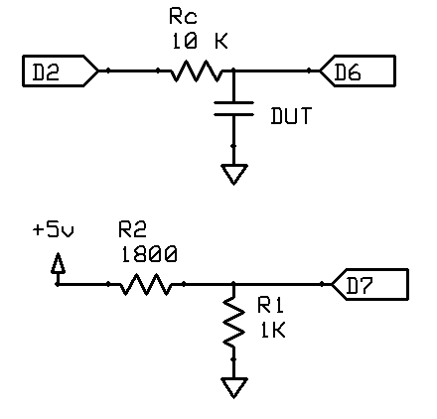
  (DUT = Device Under Test, namely the capacitor)
  /*
  Capacitance meter
  Author: Nick Gammon
  Date: 2 July 2013
  Pulse pin (D2): Connect to capacitor via 10K resistor (Rc)
  Reference voltage connected to D7 (AIN1) as per below.
  Measure pin (D6 - AIN0) connected to first leg of capacitor, other leg connected to Gnd.
  Like this:
  Capacitor to test:
  D2 ----> Rc ----> D6 ----> capacitor_under_test ----> Gnd
  Reference voltage:
  +5V ----> R2 ---> D7 ---> R1 ----> Gnd
  */
  const byte pulsePin = 2; // the pin used to pulse the capacitor
  const float Rc = 10000; // charging resistor
  const float R1 = 1000; // between ground and D7
  const float R2 = 1800; // between +5V and D7
  const float clockRate_us = 16; // 16 MHz
  const float k = 1000 / (clockRate_us * Rc * log ((R1 + R2) / R2));
  volatile boolean triggered;
  volatile boolean active;
  volatile unsigned long timerCounts;
  volatile unsigned long overflowCount;
  ISR (TIMER1_OVF_vect)
  {
  ++overflowCount; // count number of Counter 1 overflows
  } // end of TIMER1_OVF_vect
  ISR (TIMER1_CAPT_vect)
  {
  // grab counter value before it changes any more
  unsigned int timer1CounterValue;
  timer1CounterValue = ICR1; // see datasheet, page 117 (accessing 16-bit registers)
  unsigned long overflowCopy = overflowCount;
  if (active)
  {
  // if just missed an overflow
  if ((TIFR1 & bit (TOV1)) && timer1CounterValue < 0x7FFF)
  overflowCopy++;
  // calculate total count
  timerCounts = (overflowCopy << 16) + timer1CounterValue; // each overflow is 65536 more
  triggered = true;
  digitalWrite (pulsePin, LOW); // start discharging capacitor
  TCCR1B = 0; // stop the timer
  } // end if active
  } // end of TIMER1_CAPT_vect
  void setup ()
  {
  pinMode (pulsePin, OUTPUT);
  digitalWrite (pulsePin, LOW);
  Serial.begin (115200);
  Serial.println ("Started.");
  ADCSRB = 0; // (Disable) ACME: Analog Comparator Multiplexer Enable
  ACSR = bit (ACIC); // Analog Comparator Input Capture Enable
  DIDR1 |= bit (AIN1D) | bit (AIN0D); // Disable digital buffer on comparator inputs
  PRR = 0;
  } // end of setup
  void startTiming ()
  {
  active = true;
  triggered = false;
  noInterrupts ();
  // prepare timer
  overflowCount = 0; // no overflows yet
  // reset Timer 1
  TCCR1A = 0;
  TCCR1B = 0;
  TCNT1 = 0; // Counter to zero
  // Timer 1 - counts clock pulses
  TIMSK1 = bit (TOIE1) | bit (ICIE1); // interrupt on Timer 1 overflow and input capture
  // get on with it
  digitalWrite (pulsePin, HIGH); // start charging capacitor
  // start Timer 1, no prescaler
  TCCR1B = bit (CS10) | bit (ICES1); // plus Input Capture Edge Select
  interrupts ();
  } // end of startTiming
  void finishTiming ()
  {
  active = false;
  Serial.print ("Capacitance = ");
  float capacitance = (float) timerCounts * k;
  Serial.print (capacitance);
  Serial.println (" nF");
  triggered = false;
  delay (3000);
  } // end of finishTiming
  void loop ()
  {
  // start another test?
  if (!active)
  startTiming ();
  // if the ISR noted the time interval is up, display results
  if (active && triggered)
  finishTiming ();
  } // end of loop
  Discussion
  Discussion about this project on these Arduino forum threads:
  Measuring capacitance with an oscilloscope
  Turn your Arduino into a capacitor tester ...
  - Nick Gammon
  www.gammon.com.au, www.mushclient.com
  top

The dates and times for posts above are shown in Universal Co-ordinated Time (UTC).
To show them in your local time you can join the forum, and then set the 'time correction' field in your profile to the number of hours difference between your location and UTC time.

14,356 views.
Postings by administrators only.
Refresh page
Top of Form
Go to topic: Search the forum
Bottom of Form

top
Quick links: MUSHclient. MUSHclient help. Forum shortcuts. Posting templates. Lua modules. Lua documentation.
Information and images on this site are licensed under the Creative Commons Attribution 3.0 Australia License unless stated otherwise.


Comments to: Gammon Software support
Forum RSS feed ( https://gammon.com.au/rss/forum.xml )

